**Common OS functions comparison sheet**

**File systems**

1. Find the path to your home folder (the one that is named after you) on both the linux and windows systems. Write down the paths. Windows: C:\Users\Kevin
2. What is the name of the file system for each OS. Find a system utility that will display that information for you. Use the MS snipping tool to take a screen shot and place it here. DOS:FAT

Win 95:FAT16 Win 3:FAT16

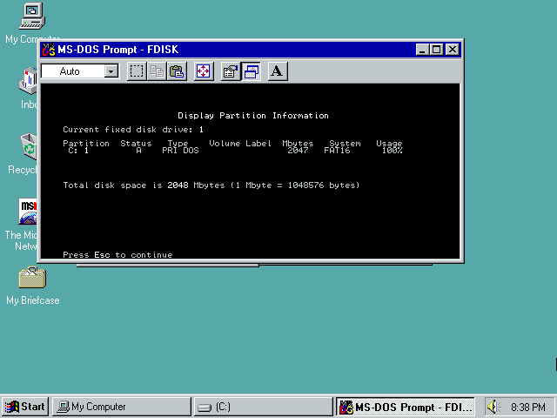

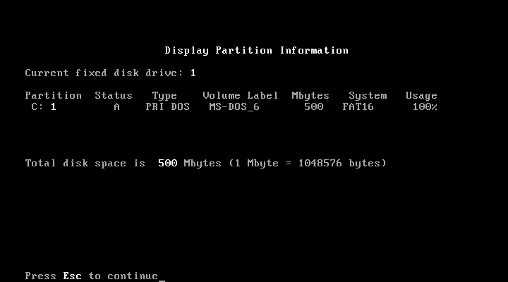

1. What is the root of the file system for each operating system? C:\
2. What information / options / attributes does your OS support on files. Find the file properties for a word processing document in each file system. Us the snipping tool to take a screen shot of the file properties in each OS. Describe one way in which the systems are the same and one way in which the systems are different.

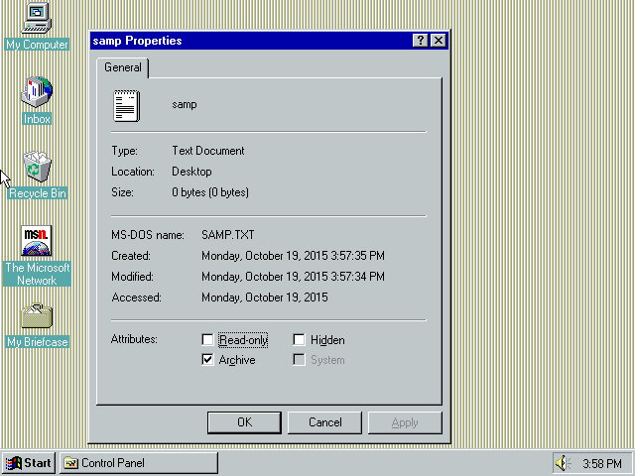 You can rename files, change the file extension, edit the file(with right app/utility).

They all have a root but have different ways of storing files/folders.

**Users and Groups**

1. Describe the process of creating a new user in both OS systems. Use the snipping tool to take a screen shot of the last step in this process (right before the new user is created.)
2. Each OS has a system utility for managing user access rights on individual files. Find that utility for a word processing file, take a screen shot of it, and post it here.

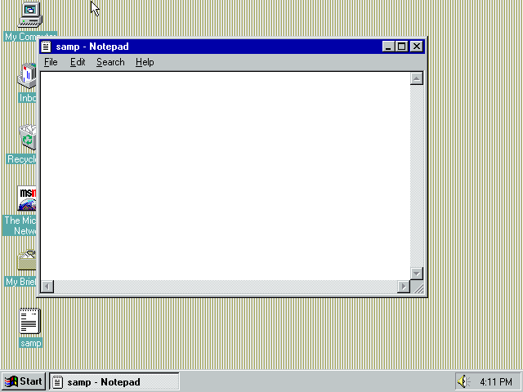

1. Each OS has a way of changing the user’s password for their user account. Find this and post a screen shot.

**User Interface**

1. What are the two kinds of User Interfaces supported and included in all 3 of the major operating systems? GUI CLI
2. Find the CLI interface for each OS. Post a screenshot of them. Dos IS one 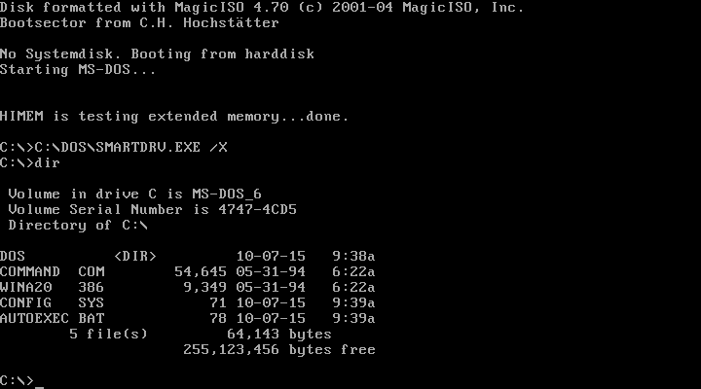

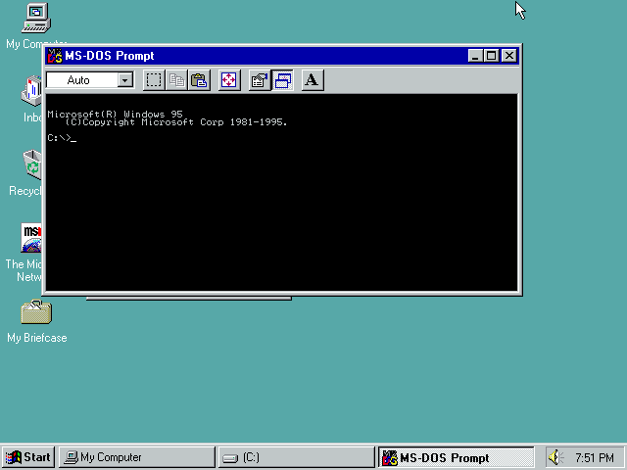

1. OS’s have the ability to change the appearance and user preferences. Describe the process of changing the theme on each OS. Find the utility that controls this process and post a screen shot. Go in control panel and click display.

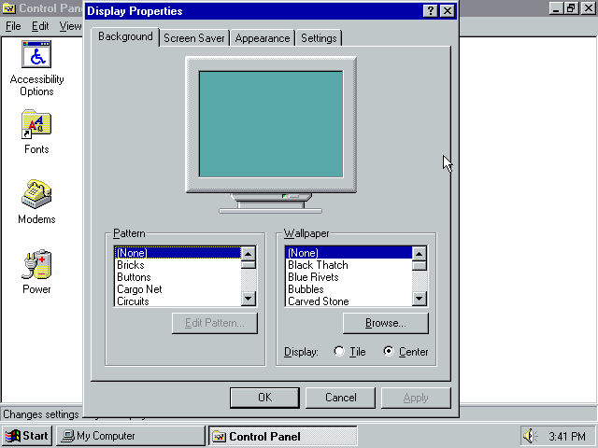

1. Describe the process of Installing software on Windows and Linux. How are they the same? How are they Different? How about software updates? How about older versions of Windows?

**Utilities**

1. Find the network management utility in each operating system and take a screen snip of both.

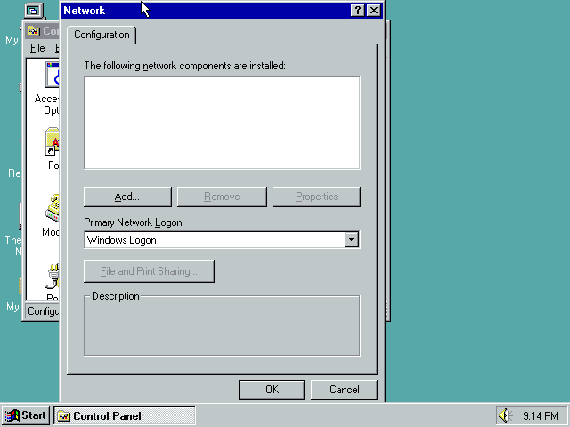

1. Each OS systems contain a way to show the currently running processes on the system (called the task manager on Windows). Find these, and post a screen shot. 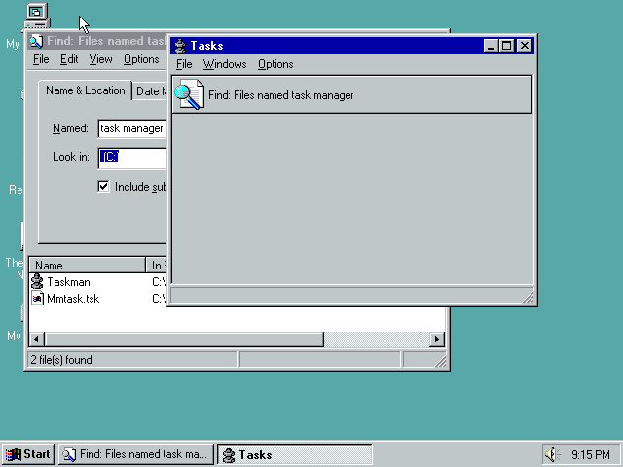
2. Locate a Utility that displays each system’s hardware details, such as processor, RAM, and OS details, and post screen snips of these windows.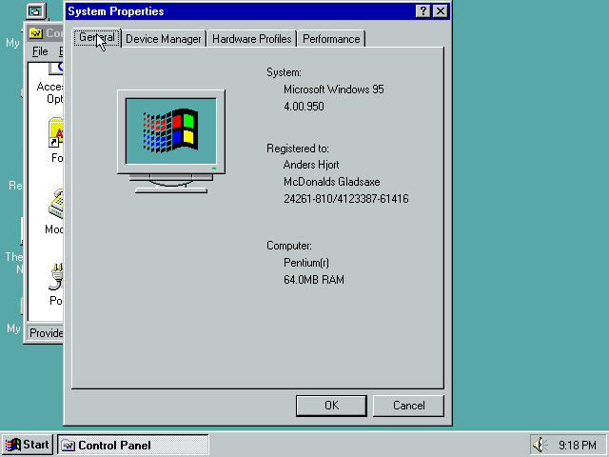
3. Locate a Utility for Disk Drive Maintenance, such as Defragmentation, in each OS, and post snips.

